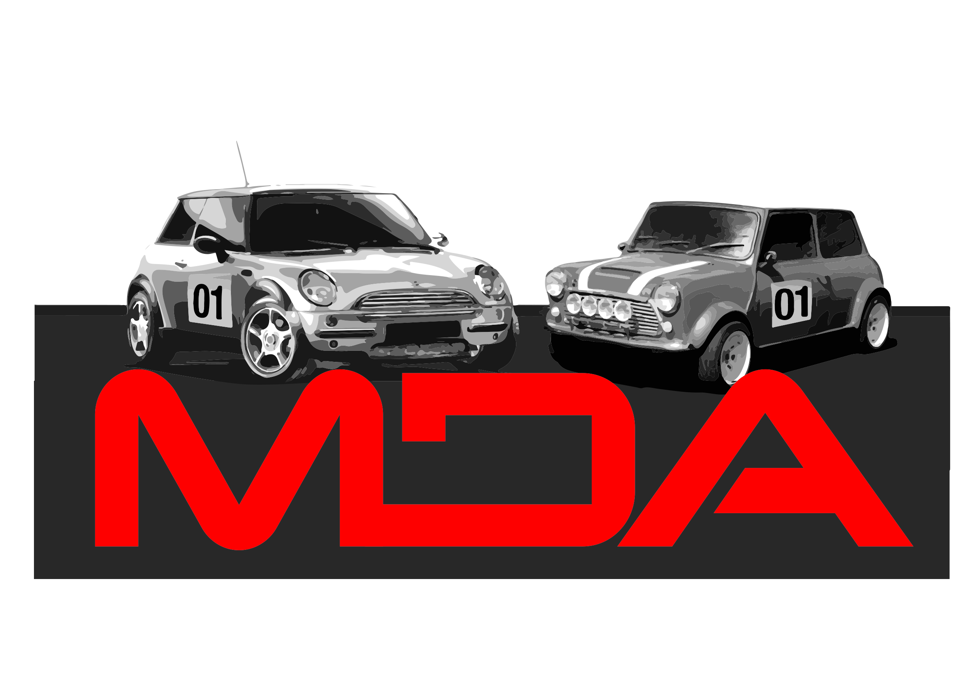
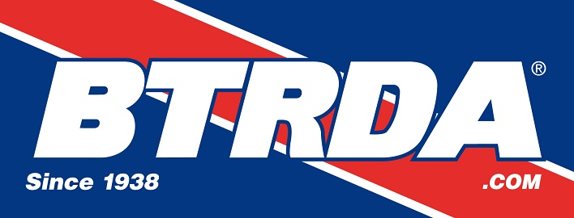
MDA/Blyton Park Rallycross Event
Blyton Park, Sunday 26th June 2022

Official Entry Form

Driver Name …......................................................

Address …...........................................................................................
…............................................................................................
…............................................................................................
Post code …..................

Telephone ….................................... Mobile ….........................................

Email Address …...........................................................................................

MDA Membership Number ….............................................

Invited Club Name and Membership Number ..................................................

Vehicle Make/Model …................................................ Engine CC …...................

Class Entered …................................... Championship Race No' ….................

Licence Number …................................. Transponder Number ….....................

Next of Kin details (Name and Telephone Number)

…............................................................. Tel …....................................

Held under the General regulations of Motorsport UK (Incorporating the provisions of the International Sporting Code of the FIA) and any Supplementary Regulations issued.

ENTRY FORMS AND PAYMENT MUST BE RECEIVED BY 16th June 2022
Entry Fee £260.00
Or £230.00 for MDA Members

Entry forms to be emailed to entries@mini-cross.co.uk

Bank Transfers to be made to Minicross Driver's Associaton account
Sort Code 60-17-28 Account Number 90255259 – make sure you note the payment date on this form and the account name if different to the entrant name.

Due to Covid-19 restrictions, entries MUST be made by email and payment made by Bank Transfer (BACS) or PayPal (through the website portal)

** PLEASE ENSURE THAT YOU HAVE READ AND SIGNED THE DECLARATION ON THE BOTTOM OF THIS FORM AND ALL PARTS OF THE FORM ARE COMPLETED **

Indemnities Declarations & Undertakings by Entrants & Drivers

I declare that I have been given the opportunity to read the General Regulations of the Motorsport UK and, if any, the Supplementary Regulations for this event and agree to be bound by them. I declare that I am physically and mentally fit to take part in the event and I am competent to do so. I acknowledge that I understand the nature and type of competition and the potential risk inherent with motor sport and agree to accept that risk. I understand that motor sport can be dangerous and
accidents causing death, injury, disability and property damage can and do happen. I understand that these risks may give rise to my suffering personal injury or other loss and I acknowledge and accept these risks.

In consideration of the acceptance of this entry I agree that neither any one of or any combination of Motorsport UK and its associated clubs, the organisers, the track owners or other occupiers, the promoters and their respective
officers, servants, representatives and agents (the “Parties”) shall have any liability for loss or damage which may be sustained or incurred by me as a result of participation in the Event including but not limited to damage to property,
economic loss, consequential loss or financial loss howsoever caused. Nothing in this clause is intended to or shall be deemed to exclude or limit liability for death or personal injury. To the fullest extent permitted by law I agree to
indemnify and hold harmless each of the Parties in respect of any loss or damage whatsoever and howsoever arising from my participation in this event

To the best of my belief the driver(s) possess(es) the standard of competence necessary for an event of the type to which this entry relates and that the vehicle entered is suitable and roadworthy for the event having regard to the course and
the speeds which will be reached.

I understand that should I at the time of this event be suffering from any disability whether permanent or temporary which is likely to affect prejudicially my normal control of the vehicle, I may not take part unless I have declared such
disability to the ASN which has, following such declaration, issued a licence which permits me to do so.

I undertake that at the time of the event to which this entry relates I shall have passed or am exempt from an ASN specified
medical examination within the specified period. (H10.1.6)
I have read and fully understood the Regulations for Control of Drugs and Alcohol as contained in the Competitors' and Officials' Yearbook Regulations C1.1.7, D35.1, G15.1.4, H38 and have also fully familiarised myself with the information on the websites referred to (www.motorsportuk.org and www.ukad.org.uk and www.wada-ama.org) in particular the UK Anti Doping Rules which have been adopted by the Motorsport UK. Further, if I am counter-signing as the Parent or Guardian of a minor then in addition to the deemed consent to the testing of that minor (UKAD Code Art 5.7.2) I hereby confirm that I give such consent for the minor concerned to be so tested.

I hereby agree to abide by the Motorsport UK Safeguarding Policy and Guidelines and the National Sporting Code of Conduct.

I also agree to comply with all instructions relating to procedural changes due to Covid-a9 (Coronavirus)

Drivers signature : …..................................................... Age if Under 18 ……………………..

If I am the parent/guardian/guarantor of the driver, I understand that I shall have the right to be present during any procedure being carried out under the Supplementary Regulations issued for this event and the General Regulations of Motorsport UK.

As the parent/guardian/guarantor I confirm that I have acquainted myself with the Motorsport UK General Regulations, agree to pay any appropriate charges and fees pursuant to those Regulations (to include any appendices thereto) and hereby agree to be bound by those regulations and submit myself without reserve to the consequences resulting from the regulations (and any alteration thereof). Further, I agree to pay as liquidated damages any fines imposed upon me up to the maximum set out in Section Z.

Parent/\Guardian signature : ….....................................................

This entry is made with my consent. Parent/Guardian/Guarantor is deemed to be the Entrant where the driver is under 18 years of age.

Full name of Parent/Guardian/Guarantor …................................................

Address ….............................................................................................

….............................................................................................

Relationship to Driver ….........................................................................

Date …..........................................

PADDOCK SPACE IS LIMITED – IF YOU NEED SPACE FOR A LARGE VEHICLE OR AWNING PLEASE GIVE DETAILS TO HELP WITH THE PADDOCK PLAN

