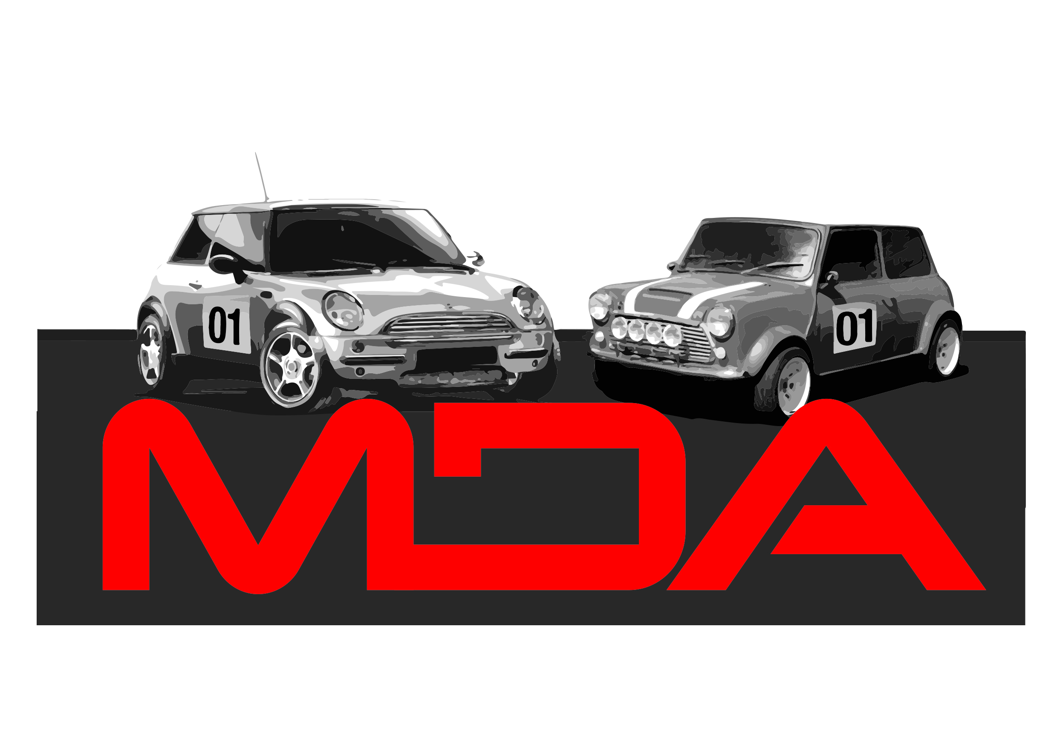
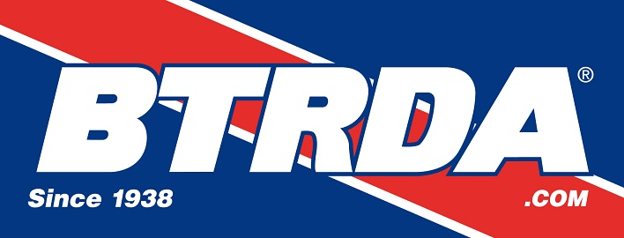
MDA/Blyton Park Rallycross Event
Blyton Park, Sunday 24th March 2019

Official Entry Form
Inviting all competitors of the
2019 Autosport International BTRDA Clubman's Rallycross Championship
in Partnership with Toyo Tyres

Driver Name …......................................................

Address …...........................................................................................
…............................................................................................
…............................................................................................
Post code …..................

Telephone ….................................... Mobile ….........................................

Email Address …...........................................................................................

MDA Membership Number ….............................................

Invited Club Name and Membership Number ..................................................

Vehicle Make/Model …................................................ Engine CC …...................

Class Entered …................................... Championship Race No' ….................

Licence Number …................................. Transponder Number ….....................

Next of Kin details (Name and Telephone Number)

…............................................................. Tel …....................................

Held under the General regulations of The Motor Sports Association Ltd (Incorporating the provisions of the International Sporting Code of the FIA) and any Supplementary Regulations issued.

ENTRY FORMS AND PAYMENT MUST BE RECEIVED BY 14th March 2019
Entry Fee £240.00 (Cheques Banked & Charged 7 days prior to the meeting)
Or £200.00 for MDA Members (Membership cost £40.00)

Entry forms to be returned to :
Sam O’Flanagan, 1 Godlings Way, Braintree, Essex, CM7 1HW
Entry forms can also be e mailed to the event secretary at; entries@mini-cross.co.uk

Bank Transfers (Preferred method) can be made to Minicross Driver's Associaton account
Sort Code 60-17-28 Account Number 90255259 – if paying by bank transfer make sure you note the payment date on this form and the account name if different to the entrant name.

Cheques to be payable to: “Minicross Drivers' Association”

** PLEASE ENSURE THAT YOU HAVE READ AND SIGNED THE DECLARATION ON THE BOTTOM OF THIS FORM AND ALL PARTS OF THE FORM ARE COMPLETED **

Indemnities Declarations & Undertakings by Entrants & Drivers

I declare that I have been given the opportunity to read the General Regulations of the Motor Sports Association and, if any, the Supplementary Regulations for this event and agree to be bound by them. I declare that I am physically and mentally fit and competent to take part in the event. I understand that motorsport is dangerous and accidents causing death, injury, disability and property damage can, and do, happen. I understand that these risks may give rise to my suffering personal injury or other loss and I acknowledge and accept these risks.

In consideration of the acceptance of this entry I agree that neither any one of or any combination of the MSA and its associated clubs, the organisers, the track owners or other occupiers, the promoters and their respective officers, servants, representatives and agents (The “Parties”) shall have any liability for loss or damage which may be sustained or incurred by me as a result of participation in the Event. Nothing in this clause is intended or shall be deemed to exclude or limit liability for death or personal injury. To the fullest extent permitted by law I agree to indemnify and hold harmless each of the Parties in respect of any loss or damage whatsoever and howsoever arising from my participation in the Event.

I declare that to the best of my belief the driver possesses the standard of competence necessary for an event of the type to which this entry relates and that the vehicle entered is suitable and roadworthy for the event, having regard to the course and the speeds which will be reached.

I understand that should I, at the time of the event, be suffering from any disability, whether permanent or temporary, which is likely to affect prejudicially my normal control of my vehicle, I may not take part unless I have declared such disability to the ASN which has, following such declaration, issued a licence which permits me to do so.

I have read and fully understood the Procedure for Control of Drugs and Alcohol as contained in the Competitors' and Officials' Yearbook Regulations H39, D35.1, G15.1.4 and have also fully familiarised myself with the information on the websites referred to (www.ukad.org.uk and www.wada-ama.org) in particular the UK Anti Doping Rules which have been adopted by the MSA (as amended). Further, if I am counter-signing as the Parent or Guardian of a minor then in addition to the deemed consent to the testing of that minor (UKAD Code Art 5.6.2) I hereby confirm that I give such consent for the minor concerned to be so tested.

Drivers signature : ….....................................................

If I am the parent/guardian/guarantor of the driver, I understand that I shall have the right to be present during any procedures being carried out under the Supplementary Regulations issued for this event and the General Regulations of the MSA.

As the parent/guardian/guarantor I confirm that I have acquainted myself with the MSA General Regulations, agree to pay any appropriate charges and fees pursuant to those Regulations (to include any appendices thereto) and hereby agree to be bound by those regulations and submit myself without reserve to the consequences resulting from the regulations (and any alteration thereof). Further, I agree to pay as liquidated damages any fines imposed upon me up to the maximum set out in Section Z.

Parent/\Guardian signature : ….....................................................

This entry is made with my consent. Parent/Guardian/Guarantor is deemed to be the Entrant where the driver is under 18 years of age.

Full name of Parent/Guardian/Guarantor …................................................

Address ….............................................................................................

….............................................................................................

Relationship to Driver ….........................................................................

Date …..........................................

PADDOCK SPACE AT BLYTON IS LIMITED – IF YOU NEED SPACE FOR A LARGE VEHICLE OR AWNING PLEASE GIVE DETAILS BELOW TO HELP WITH THE PADDOCK PLAN

…...........................................................................................................................................................................

…...........................................................................................................................................................................

